INTERNATIONAL CONFERENCE ON DEVELOPMENT EDUCATION
November 1-3, 2018
Philippine School Doha, Doha, Qatar

OBSERVER REGISTRATION FORM

Theme: “The Role of Development Education in the Transformation of Individuals, Communities and Societies”
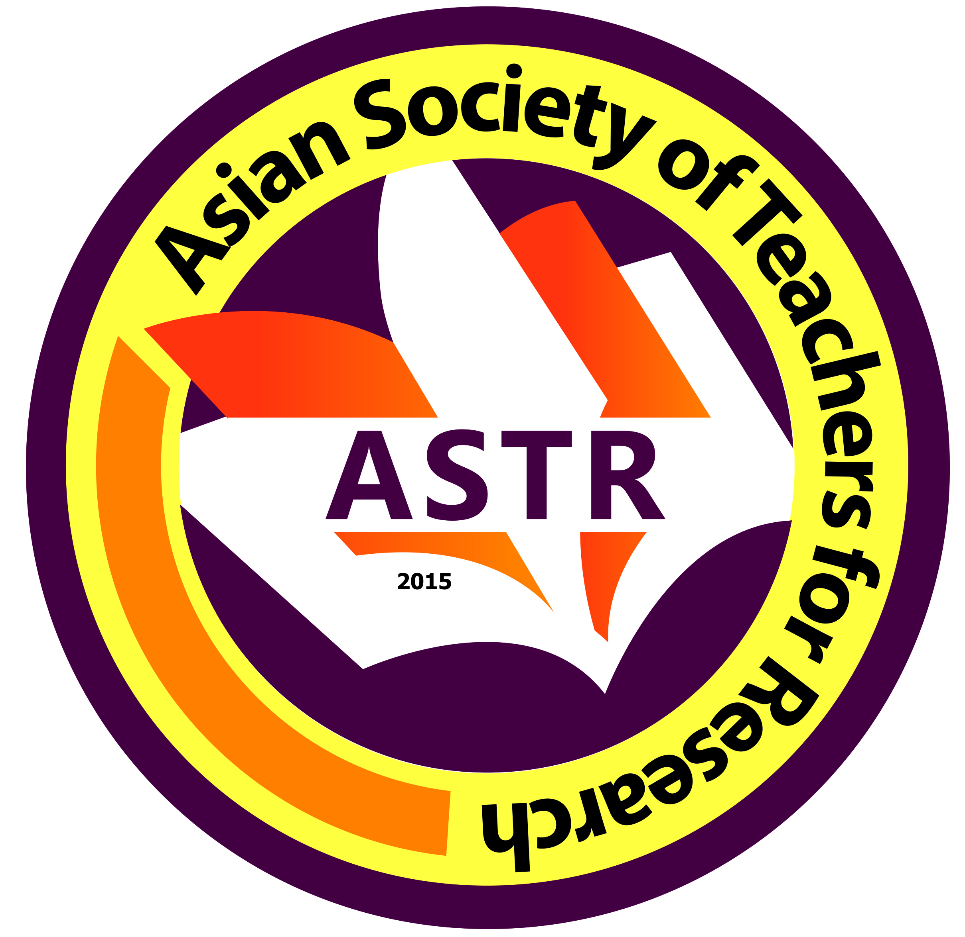
Date Filed:

First Name:
Middle Name:
Last Name:
Email Address:
Mobile No. (begin with country code):
ORCID No (register at www.orcid.org):
Field(s) of Expertise:
Organization/School/University/Affiliation:
Address of Organization/School/University/Affiliation:

*Please attached the following documents together with this filled-out form:
(a) formal ID Photo;
(b) Updated Curriculum Vitae;
(c) deposit slip

